Moving sound

A loudspeaker vibrates and makes a sound.
We hear the sound because a sound wave moves through the air.


These pictures try to show how a sound wave moves through the air.
Which one is the best model for how a sound wave moves?

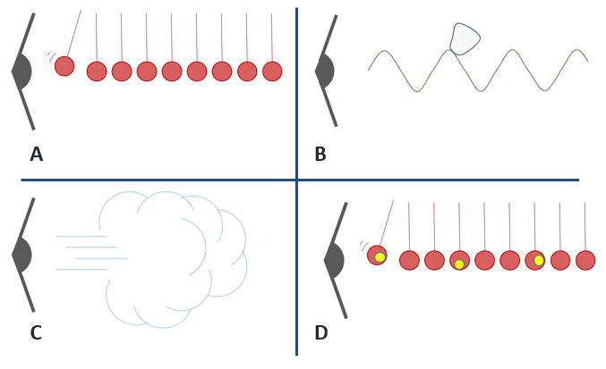

Physics > Big idea PSL: Sound, light and waves > Topic PSL4: Waves > Key concept PSL4.2: A wave model of sound
Diagnostic question
Moving sound

Overview
Learning focus: | As a sound wave (longitudinal wave) travels it transfers energy, as particles of the medium through which it travels are successively made to vibrate forwards and backwards along the direction in which the wave travels.
Observable learning outcome: | Recognise that as a sound wave travels forward, the medium it travels through does not.
Question type: | Simple multiple choice
Key words: | Sound wave, vibrate, vibration

P | PRIOR UNDERSTANDING  This diagnostic question probes understanding of ideas that are usually taught at age 5-11, to aid transition from earlier stages of learning.

What does the research say?
The transmission of sound is difficult to understand. It is common for students to think of sound as a material substance that moves from one place to another (Barman, Barman and Miller, 1996). Even at degree level Linder (1992) found that some students thought of sound as a ‘lump’ of material travelling through a passive medium, similar to a surfer on a water wave. In a study of 15- to 16-year-old science students (n=243) Caleon and Subramaniam (2010) found that over 60% thought that as sound moves through a medium, it carries or pushes the particles of the medium forward. The most common misunderstanding was that sound is an entity, passed or carried from particle to particle in a collision-like process.
Finding out exactly what students are thinking about sound can be difficult, as they often label ideas of ‘sound particles’ with scientific terms: sound waves, disturbances, or vibrations. Superficially it can appear that students have a scientific understanding when they do not (Fazio et al., 2008).
Ways to use this question
Students should complete the question individually. This could be a pencil and paper exercise, or you could use an electronic ‘voting system’ or mini white boards and the PowerPoint presentation.
The answers to the question will show you whether students understood the concept sufficiently well to apply it correctly.
If there is a range of answers, you may choose to respond through structured class discussion. Ask one student to explain why they gave the answer they did; ask another student to explain why they agree with them; ask another to explain why they disagree, and so on. This sort of discussion gives students the opportunity to explore their thinking and for you to really understand their learning needs.
Differentiation
You may choose to read the questions to the class, so that everyone can focus on the science. In some situations it may be more appropriate for a teaching assistant to read for one or two students.
Expected answers
Correct answer is A
How to respond - what next?
Answer A shows a series of particles bashing into each other and is the best of these models. It shows the first particle being ‘bumped’ by the vibrating speaker and then passing the ‘bump’ along. It is inaccurate because in the air there are many, many more particles passing on the vibration, and they are not hanging on strings. In fact there are roughly five thousand times more particles in each centimetre cubed of air, than number of seconds in the entire history of the universe so far!
B shows the ‘surfer model’ with a lump of sound being pushed through the air by a wave of air particles. This model is a combination of the misunderstanding that sound is a material substance and the idea that sound is a wave.
C shows the naïve idea of sound moving as a gust of air.
D shows a series of particles bashing into each other and passing on ‘something’ as they do so. This represents ‘sound’ passed or carried from particle to particle in a collision-like process.
If students have misunderstandings about how sound travels, it might be helpful for them to be given the opportunity to explain why the other models are wrong. Working in pairs or small groups can encourage social construction and consolidation ideas through dialogue.
The following BEST ‘response activity’ could also be used in follow-up to this diagnostic question:
- Response activity: Model sound wave
Acknowledgments
Developed by Peter Fairhurst (UYSEG), from the BEST diagnostic question ‘Into the air’ in topic PSL1: Sound and light.
Images: Peter Fairhurst (UYSEG)
References
Barman, C. R., Barman, N. S. and Miller, J. A. (1996). Two teaching methods and students' understanding of sound. School Science and Mathematics, 96(2), 63-67.
Caleon, I. and Subramaniam, R. (2010). Development and Application of a Three-Tier Diagnostic Test to Assess Secondary Students' Understanding of Waves. International Journal of Science Education, 32:7, 939-961.
Fazio, C., et al. (2008). Modelling Mechanical Wave Propogation: Guidelines and experimentation of a teaching-learning sequence. International Journal of Science Education, 30:11, 1491-1530.
Linder, C. J. (1992). Understanding sound:so what is the problem? Physics Education, 27, 258-264.

